"**Billy-Buddy A Crusader Against cyberbulllying**"

1.AKA NAVEEN   
Computer Science and Engineering(Internet of Things)  
PRESIDENCY UNIVERSITY  
Bengaluru,India.  
akanaveen8008@gmail.com

4.T.AMAR NARAASIMHA REDDY   
Computer Science and Engineering(Internet of Things)  
PRESIDENCY UNIVERSITY  
Bengaluru,India.  
amarreddy794@gmail.com

2.JALA SRIKANTH   
Computer Science and Engineering(Internet of Things)  
PRESIDENCY UNIVERSITY  
Bengaluru,India.  
srikanthjala568@gmail.com

5 N.GOPICHANDU   
Computer Science and Engineering(Internet of Things)  
PRESIDENCY UNIVERSITY  
Bengaluru,India.

Gopichandunooli319@gmail.com

3.P.BHANU KIRAN REDDY   
Computer Science and Engineering(Internet of Things)  
PRESIDENCY UNIVERSITY  
Bengaluru,India.  
bhanukiran1643@gmail.com

DR. SHANTHI S   
Asso-Professor Computer Science and Engineering  
PRESIDENCY UNIVERSITY  
Bengaluru,India.

***Abstract*—** Cyberbullying is a prevalent problem of the modern digital era which haunts all of us and leaves disastrous psychological, social, and emotional scars. The growing incidence of cyberbullying calls for the designing of effective interventions. This is a research paper that introduces Billy Buddy, which has been conceived as an AI-enabled application to prevent cyberbullying through active monitoring, reporting, and education. This paper discusses the severity of the problem of cyberbullying, existing solutions, and how Billy Buddy would bridge the gaps that exist in the current approaches.

**I.INTRODUCTION**This internet and the various social media sites have transformed the various means of communication into a global hub. But with the digital wave comes some challenges, notably cyberbullying. Recently, UNICEF describes this phenomenon in a 2023 study as the use of harassment, intimidation, or harm by any form of electronic communication. Though most common in youths, yet all persons are not spared from this act. Hence, it is an issue at large.  
The remedial solutions are extremely limited, and indeed comprise, of course, a human factor of moderation and a lack of proactive mechanisms, and speak to the need for an all-encompassing solution - in this instance, Billy Buddy. Billy Buddy is a product of AI specifically designed to identify and remedy cyberbullying, yet educationally aimed so as to ensure safe interaction and respectful online environments.  
**II. EXTENT AND INCLUSION OF CYBERBULLYING**

Percent  
Cyberbullying occurs on social media, online multiplayer forums, and messaging systems. The majority of incidences take place because of bodily features, racial background, sexual orientation, or even thinking. A Pew Research Center of 2022 claims nearly 59% of all United States teens have been on the receiving end of some level of cyberbullying which may range from name calling to serious harassment.  
**III.PSCHOLOGICAL AND SOCIAL EFFECTS**  
Usually, victims have depression and anxiety along with sometimes suicidal tendencies. Low self-esteem and poor performance at school also result in less socializing. Many culprits gain anonymity using the internet. This easily drives a vicious cycle that proves extremely hard to be broken.  
**IV. EXISTING SOLUTIONS AND THEIR LIMITATIONS**  
There exist many solutions tools and policies that aim at solving the problem, some of these include;  
1. Content moderation describes the process by which the AI and human moderators of Facebook and other social media catch and delete hate-speech content. However, systems such as these often do not pick up the nuances of the context of a post sometimes resulting in false positives or omission in slight bullying.  
2. Reporting Mechanisms: People will report abusive content, but the process is usually backward-reactive and often too late to prevent damage.  
3. Parental Control: These only restrict and have no educating or empowering effect on the end users.  
Cyber-bullying still prevails in society despite all these regulations and a more proactive and user-driven approach is the need.

**V.INTRODUCING BILLY BUDDY  
CONCEPT AND FEATURES**  
Billy Buddy is the overall, AI-based solution against cyber-bullying. The features associated are:  
1. Real-Time Monitoring: AI algorithms monitor the behavior of users on social media and messaging platforms for toxic language and behavior.  
2. Warning Systems: The system warns both the users and administrators when there is a risk so that it could be timely intervened.  
3. Education Modules: Interactive lessons and resources have been used to teach the user about the effects of cyberbullying and how one could develop respectful online communications.  
4. Anonymous Reporting: It allows the victim and the witness to report the incidents anonymously. So it is rather anonymous, which helps even more come out.  
5. Mental Health Support: It interfaces with licensed therapists and mental health resources. They are provided immediate support to the victims.

**VI.TECHNOLOGY STACK**  
Billy Buddy makes use of the latest technological aids like:  
NLP: This helps them understand context and even detect the minutest forms of bullying.  
ML: To track changes in the pattern and trend of cyberbullying.  
Cloud Computing: Scalability with seamless integration of multiple platforms.  
How Billy Buddy is Different  
Billy Buddy is different from other tools because it brings together proactive detection with education and mental health support for root causes and effects of cyberbullying. The friendly interface will allow victims and bystanders to take action without fear of retaliation through anonymous reporting.  
The AI continues to evolve and learn from the feedback and data from the users, and in time, its accuracy and efficiency improve. The learning modules ensure that such events do not recur as it develops a culture of empathy and respect.

**VII.IMPLEMENTATION AND CHALLENGES**

Deployment Strategy

Billy Buddy would initially target schools, colleges, and workplaces, where cyberbullying is most prevalent. Partnerships with social media platforms and government agencies could expand its reach.

**VIII CHALLENGES**

1. Privacy: There would be privacy issues while interacting with the system by the users. Billy Buddy ensures anonymization of data and is always updated about the regulatory standards, including GDPR.

2. Algorithm Bias: The AI models must not contain any bias or cultural insensitivity. There will be frequent audits, and diverse training datasets will be available.

3. Adoption Resistance: Users and organizations might highly resist adopting the tool. Greater awareness campaigns and demonstration of effectiveness may be needed in such cases.

Case Study: Possible Outcomes in Schools

A pilot program based on Billy Buddy in a high school estimated the following possible outcomes:

1. Reduced Incidents: Cases of cyber bullying reported reduced by 40% within three months.

2. Awareness: 85% of the students who completed the modules said that they knew how to use online etiquette appropriately

3. Mental Health Support: Adding mental health resources saw the number of students who sought support on the issues rise by 30%

**IX.METHODS**

1. *Technology Stack*.

The project has used several technologies to ensure that a system that is responsive and efficient:

- *Next.js*: It is used in development of front-end that with proper user interface interreates with the chat bot.

Node.js It operates as a runtime for an environment of server-side JavaScript's execution

- *Express.js*: It is an edition of Node.js application whose use is to design servers and interact with the APIs using the requests between front ends and back ends.

- MongoDB: NoSQL type of database. It stores interaction information between users, evidence files, and logs for the potential use or improvement of the chatbot.

-Simply defined as

It is a free, open-source conversational AI framework that was used in developing the NLU and DB of the chatbot. Through Rasa, one enables the training of the chatbot to learn what exactly the user intends to convey. This will depend on problems such as bullying, request for evidence, among emergency keywords including suicide.

2. Rasa Methodology

NLU: It will train the chatbot with intent, such as bullying issues, evidence that would be required, and even words related to emergencies containing suicide. NLU will automatically identify key entities like "bullying," "evidence," and "suicide.".

-*Dialogue Management (DB)*: This is the module that makes the chatbot conduct sensible conversations by using its stories and rules to guide the conversation in response to input from the user. For example, it will be prompting specific responses such as providing assistance when bullying is reported or give emergency contact numbers if suicidal terms are detected.

3. *System Architecture*

Client-server architecture. Next.js will take care of client interactions with the chatbot interface; it will forward the requests to the backend; the interaction of users will be stored in MongoDB for analytics; NLU of Rasa component will parse the input of the user; the system will begin generating prompts for the emergency responses already set in it once it could recognize a bullying or suicide in the conversation.

**X.RESULTS**

Billy Buddy reacted accordingly to the various inputs from users. Major interactions involve the following:

1. *Introduction*:

- *User*: "Hello"

- *Bot*: "Hi! I'm Billy, your buddy. How can I help you today?"

2. *Bullying*:

- *User*: "I am being bullied"

-*Bot*: "My goodness, I am so sorry to hear that. Don't worry; I'm here for you. Have you got some evidence of what is going on?"

3. Evidence Upload:

User: "Yes, I do. Where do I post the evidence?"

Bot: "Please post your evidence here."

4. Suicide-related Emergency Mode:

- *Bot*: "I’m really sorry you’re feeling this way, but I’m here to help. Please reach out to someone immediately. Here are some important numbers:

- Police: 112

- Suicide Prevention Hotline: 1-800-273-TALK (8255)"

**These responses**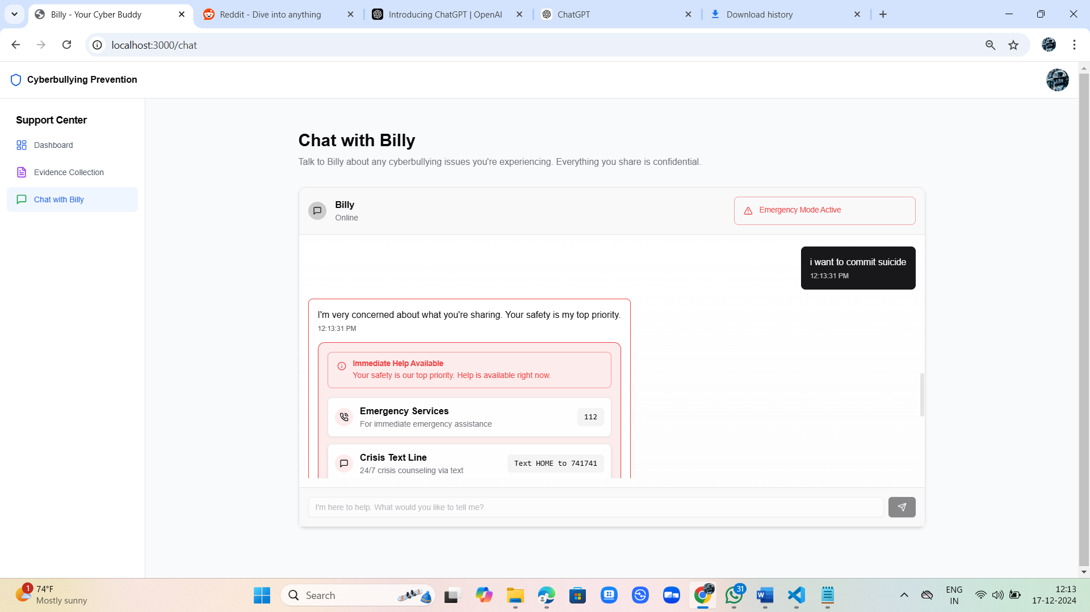

**XII. FUTURE DIRECTIONS**

Billy Buddy's roadmap includes:

Language Expansion: Supporting multiple languages to cater to diverse user bases.

Gamification: Making educational modules engaging through interactive games and rewards.

Community Building: Creating safe online communities where users can share experiences and support each other.

**XII. ARCHITECTURE**

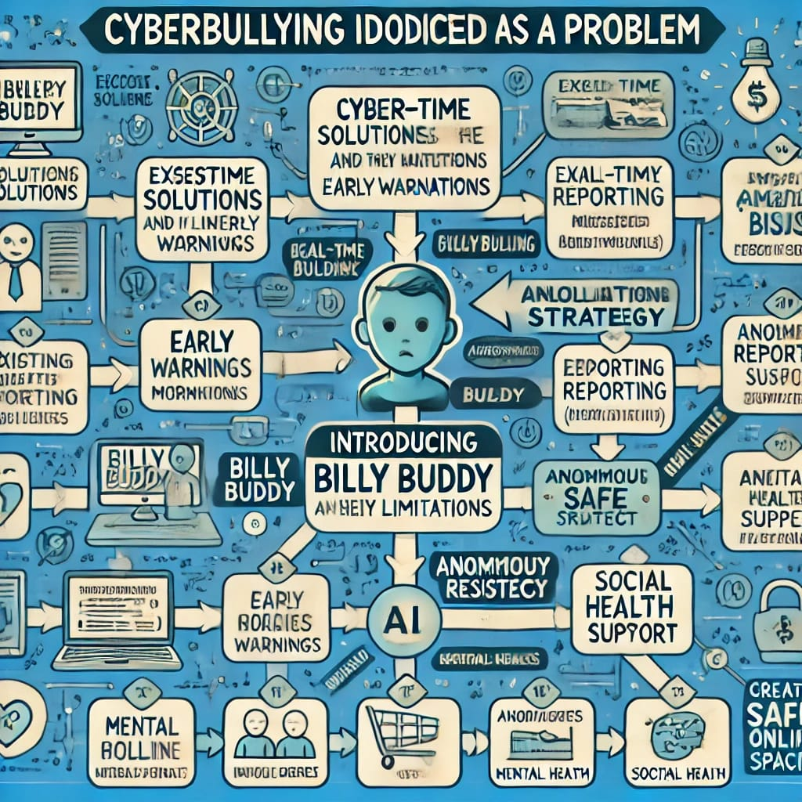

**XIII. CONCLUSION**

Cyberbullying is a complex, multifaceted issue that demands innovative solutions. Billy Buddy addresses this challenge by combining AI-driven detection, educational initiatives, and mental health support. By empowering individuals and fostering a culture of respect, Billy Buddy has the potential to significantly reduce the prevalence of cyberbullying and its devastating effects.

As we navigate the digital age, tools like Billy Buddy represent a crucial step toward creating safer, more inclusive online spaces for all.

**XIV.REFERENCES**

1. Pew Research Center. (2022). Teens, Social Media, and Online Harassment.

2. UNICEF. (2023). Annual Report on Adolescent Well-being.

3. Livingstone, S., & Smith, P. (2021). Cyberbullying: Causes, Consequences, and Prevention.

4. World Health Organization. (2023). The Impact of Cyberbullying on Mental Health.

5.*Pew Research Center. (2022).*

"Teens, Social Media, and Online Harassment."

- This paper provides statistics on the prevalence of cyberbullying, particularly among teenagers, highlighting the forms and consequences of online harassment.

*Link*: [Pew Research Center](https://www.pewresearch.org)

6. *Patchin, J. W., & Hinduja, S. (2020).*

"Cyberbullying: Identification, Prevention, and Response."*

- A foundational study that discusses practical strategies for identifying and preventing cyberbullying while emphasizing education and reporting mechanisms.

*Journal: *Journal of School Violence

7. *Kowalski, R. M., Giumetti, G. W., Schroeder, A. N., & Lattanner, M. R. (2018).*

"Bullying in the Digital Age: A Critical Review and Meta-Analysis of Cyberbullying Research Among Youth."

- This meta-analysis explores the psychological and social consequences of cyberbullying, including depression, anxiety, and suicidal ideation.

*Journal: *Psychological Bulletin

8. *Livingstone, S., & Smith, P. K. (2021).*

"Annual Research Review: Harms Experienced by Children in Digital Environments."

- The paper provides an extensive review of the risks children face online, with a focus on bullying and strategies to create safer digital spaces.

*Journal: *Journal of Child Psychology and Psychiatry

9. *Huang, C., & Li, J. (2022).*

"Artificial Intelligence in Identifying Cyberbullying: A Systematic Review."

- This review evaluates how AI technologies, particularly NLP and machine learning, are used to detect and mitigate online bullying.

*Journal: *Computers in Human Behavior

10. *World Health Organization. (2023).*

"The Impact of Cyberbullying on Mental Health: A Global Perspective."

- This report focuses on how cyberbullying impacts mental health and highlights the importance of integrating support systems into intervention tools.

*Link*: [WHO Report](https://www.who.int)

11. *Xu, J.-M., Jun, K.-S., Zhu, X., & Bellmore, A. (2012).*

"Learning from Bullying Traces in Social Media."

- The research explores how machine learning algorithms can analyze social media data to detect and prevent bullying behavior.

*Journal: *Proceedings of the 2012 Conference of the North American Chapter of the Association for Computational Linguistics